|  |
| --- |
|  |
| The Specification |
| [Type the document subtitle] |
|  |
| **[Your Name]** |
| **[Pick the date]** |

[Type the abstract of the document here. The abstract is typically a short summary of the contents of the document. Type the abstract of the document here. The abstract is typically a short summary of the contents of the document.]

Table of Contents

[To update the table of contents, right click the message below and select Update Field (F9 on PC, ⌥⌘U on Mac).]

**No table of contents entries found.**

1. Pages
   1. Page Tree

Home  
 Page 1  
 Page 2  
 Page 3

* 1. Home
     1. User Interface

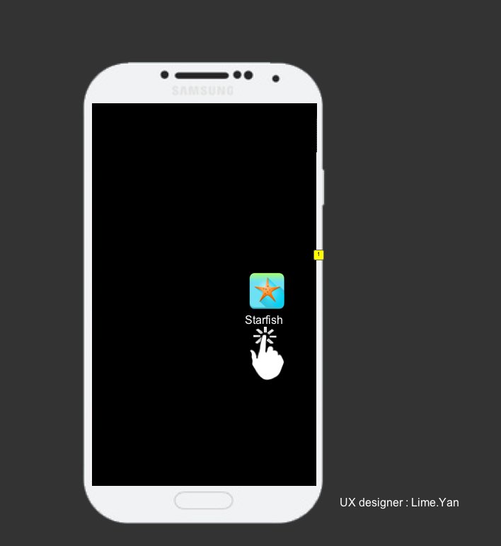

* + 1. Widget Table

| Footnote | Label | Interactions |
| --- | --- | --- |
| 1 |  | OnClick:  Case 1:  Set icon state to State1  Hide icon  Show SPLASH |

* + 1. homepage
       1. callee details
       2. User Interface

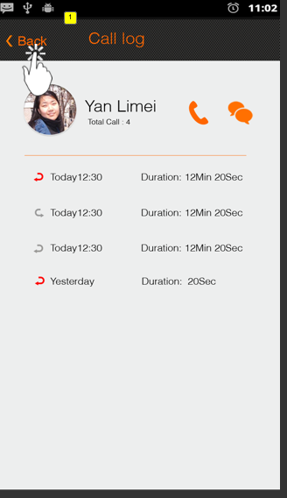

* + - 1. Widget Table

| Footnote | Interactions |
| --- | --- |
| 1 | OnClick:  Case 1:  Hide homepage  Show SPLASH  Set SPLASH state to hompage |

* + - 1. text
      2. User Interface



* + - 1. Widget Table

| Footnote | Interactions |
| --- | --- |
| 1 | OnClick:  Case 1:  Hide icon, homepage  Show SPLASH  Set SPLASH state to hompage |

* + - 1. call2options
      2. User Interface

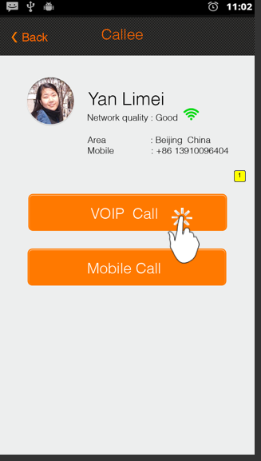

* + - 1. Widget Table

| Footnote | Interactions |
| --- | --- |
| 1 | OnClick:  Case 1:  Hide icon, SPLASH  Set homepage state to Ongoing |

* + - 1. Ongoing
      2. User Interface

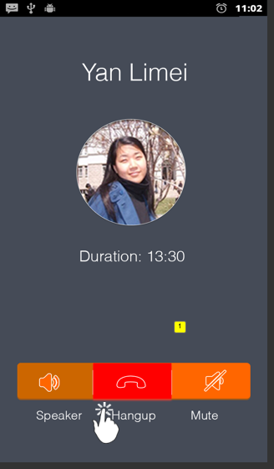

* + - 1. Widget Table

| Footnote | Interactions |
| --- | --- |
| 1 | OnClick:  Case 1:  Hide homepage, icon  Show SPLASH  Set SPLASH state to hompage |

* + - 1. call3options
      2. User Interface

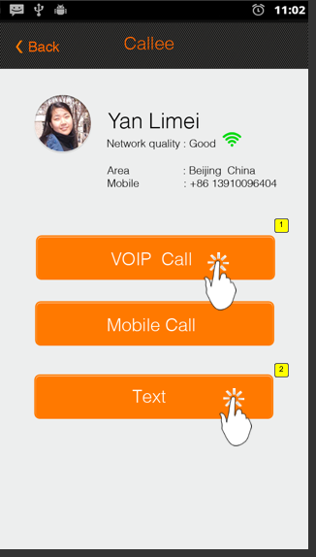

* + - 1. Widget Table

| Footnote | Interactions |
| --- | --- |
| 1 | OnClick:  Case 1:  Set homepage state to Ongoing |
| 2 | OnClick:  Case 1:  Set homepage state to text |

* + - 1. call history
      2. User Interface

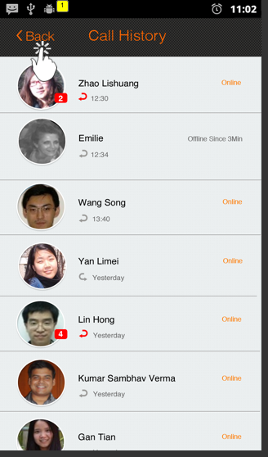

* + - 1. Widget Table

| Footnote | Interactions |
| --- | --- |
| 1 | OnClick:  Case 1:  Hide homepage  Show SPLASH  Set SPLASH state to hompage |

* + - 1. message history
      2. User Interface

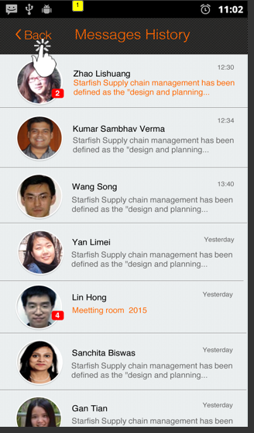

* + - 1. Widget Table

| Footnote | Interactions |
| --- | --- |
| 1 | OnClick:  Case 1:  Show SPLASH  Set SPLASH state to hompage  Hide homepage |

* + 1. SPLASH
       1. State1
       2. User Interface

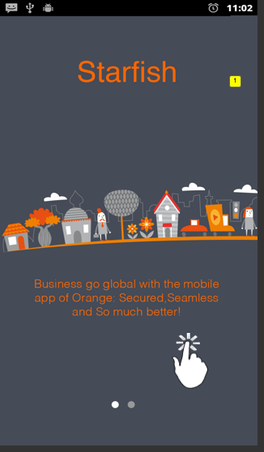

* + - 1. Widget Table

| Footnote | Interactions |
| --- | --- |
| 1 | OnClick:  Case 1:  Set SPLASH state to State2  Hide icon |

* + - 1. State2
      2. User Interface

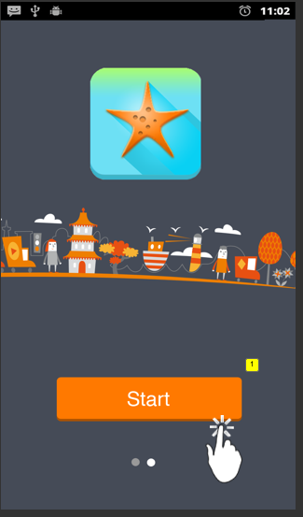

* + - 1. Widget Table

| Footnote | Interactions |
| --- | --- |
| 1 | OnClick:  Case 1:  Hide icon, SPLASH, homepage  Show login |

* + - 1. hompage
      2. User Interface

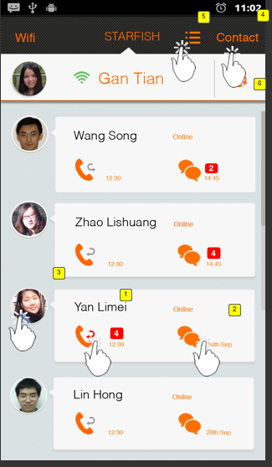

* + - 1. Widget Table

| Footnote | Interactions |
| --- | --- |
| 1 | OnClick:  Case 1:  Show homepage  Set homepage state to call2options  Hide SPLASH |
| 2 | OnClick:  Case 1:  Hide SPLASH, login, icon  Show homepage  Set homepage state to text |
| 3 | OnClick:  Case 1:  Hide SPLASH  Show homepage  Set homepage state to callee details |
| 4 | OnClick:  Case 1:  Set SPLASH state to contact slide left out 700ms  Hide icon, login, homepage |
| 5 | OnClick:  Case 1:  Show Menu bar  Hide icon, login, homepage |
| 6 | OnClick:  Case 1:  Hide Menu bar |

* + - 1. contact
      2. User Interface

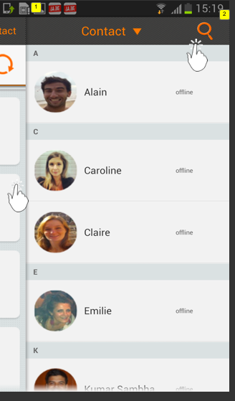

* + - 1. Widget Table

| Footnote | Interactions |
| --- | --- |
| 1 | OnClick:  Case 1:  Set SPLASH state to hompage slide right in 700ms |
| 2 | OnClick:  Case 1:  Set SPLASH state to search slide up in 500ms  Hide homepage, login, icon |

* + - 1. search
      2. User Interface

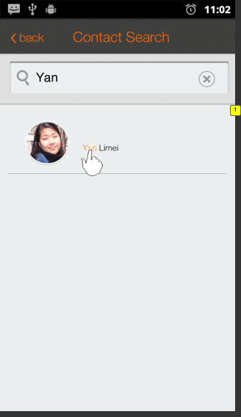

* + - 1. Widget Table

| Footnote | Interactions |
| --- | --- |
| 1 | OnClick:  Case 1:  Hide SPLASH, login, icon  Show homepage  Set homepage state to call3options |

* + 1. login
       1. State1
       2. User Interface

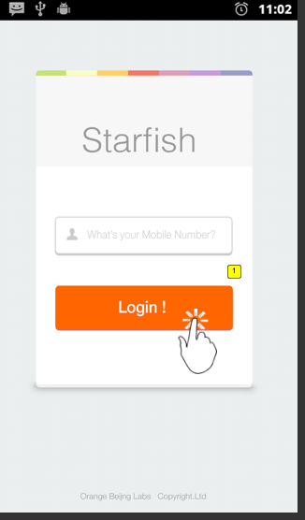

* + - 1. Widget Table

| Footnote | Interactions |
| --- | --- |
| 1 | OnClick:  Case 1:  Show SPLASH  Hide icon, homepage, login  Set SPLASH state to hompage |

* + 1. icon
       1. State1
       2. User Interface

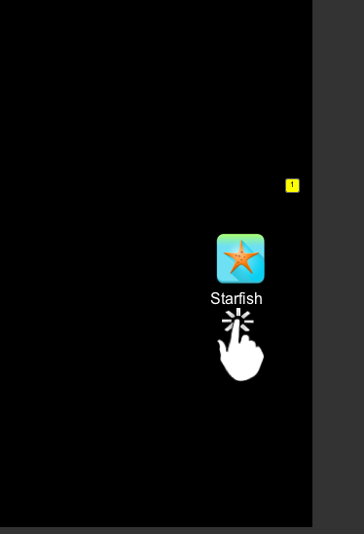

* + - 1. Widget Table

| Footnote | Interactions |
| --- | --- |
| 1 | OnClick:  Case 1:  Hide icon  Show SPLASH  Set SPLASH state to State1 |

* + 1. Menu bar
       1. State1
       2. User Interface

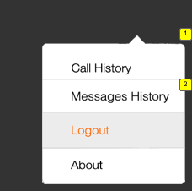

* + - 1. Widget Table

| Footnote | Interactions |
| --- | --- |
| 1 | OnClick:  Case 1:  Hide Menu bar, SPLASH  Show homepage  Set homepage state to call history |
| 2 | OnClick:  Case 1:  Hide Menu bar, SPLASH  Show homepage  Set homepage state to message history |

* 1. Page 1
  2. Page 2
  3. Page 3